Lab 1 - Setup Environment and Create First HTML Template

Instructions
- Answer the below question in the boxes if needed.
- For coding exercises, code on your computer and zip all your code before submission.
- Please submit the assignment after you finish.

Part 1: Installing VS Code
- Go to https://code.visualstudio.com/Download
- Choose the corresponding installation file for Windows, Mac or Linux.
- Accept the agreement and click on Next
- Check all of the boxes (Suggest to “Create a desktop icon” for convenience)
- Click Install

Part 2 Getting Your HTML Development Environment Setup

For developing HTML, you don’t need to install any extra tools or software. All you need is just the Visual Studio Code.
Steps:

- Pick a place that you like on your computer (e.g. Desktop), and create a new folder. Name it “M1-HTML-CSS”.

- Open the folder in Visual Studio Code
- Click on “File” -> “Open Folder”
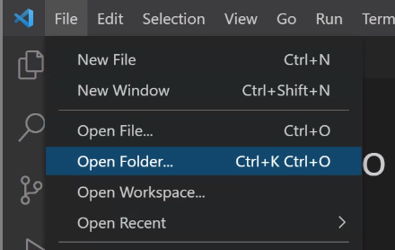

- Select The Folder and click on Select Folder
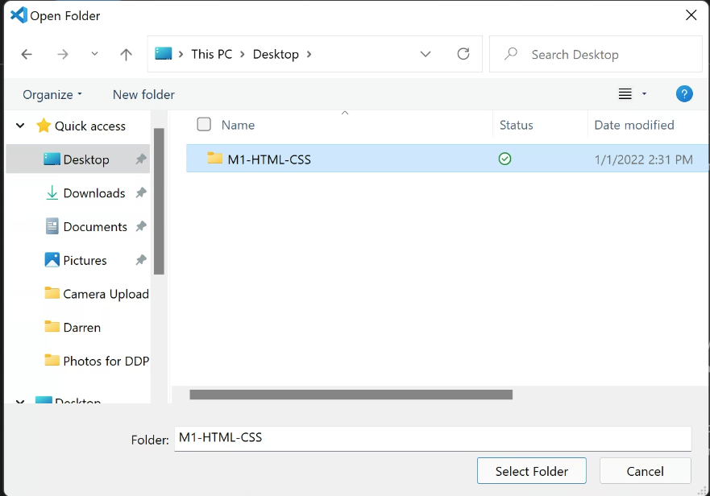

- Right click on the left section of the window, select new file and name it as “index.html”

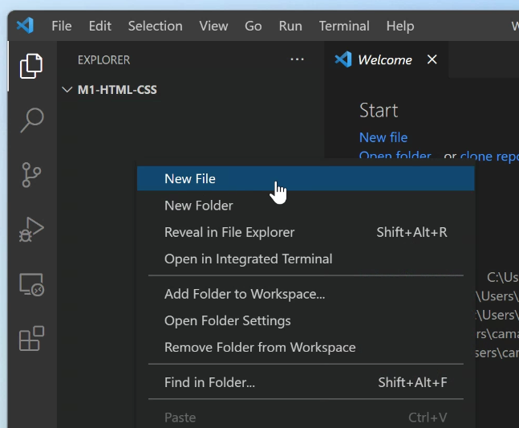

- Open the file and paste in the following content.
<!DOCTYPE html>
<html>
<head>
<title>Page Title</title>
</head>
<body>
My Home Page
</body>
</html>

- Go to Extensions and install Prettier (Enter “esbenp.prettier-vscode” in the searchbar)
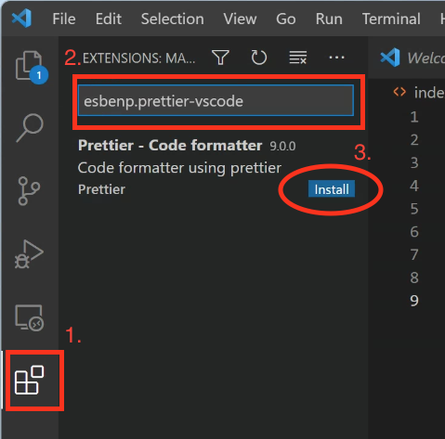

- Go to Extensions and install Live Server (Enter “ritwickdey.liveserver” in the searchbar).
- Go back to the “Explorer” tab, and right click on the “index.html” file. Then click on “Open with Live Server”. If you are successful, you will be seeing a webpage with only one line (My Home Page) being displayed in your browser.
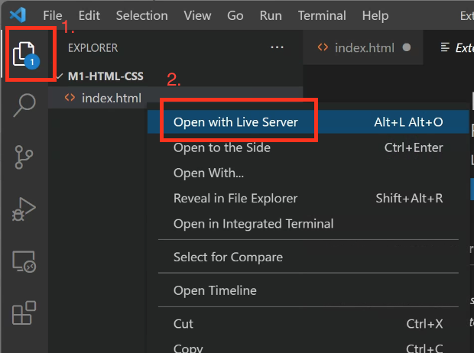

Part 3: Change Page Title to Your Name

- Change the title of the page to your name. (Hint: You can update the <title> tag in <head> part of the HTML code.)
- Screenshot the page (including title) and zip it with your HTML file. Then submit it.

